Additional Resources

Cooking Matters
At Cooking Matters.org, you can find handouts for kids ready to print.
https://cookingmatters.org/kids-handouts

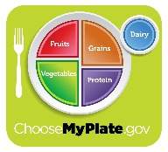
Myplate.gov
At myplate.gov, you can find printable word scrambles, coloring sheets, and ten tip sheets.
https://www.choosemyplate.gov/printable-materials

Stanford University
At Coursera.org, you can find a free online course on child nutrition and cooking.
https://www.coursera.org/learn/childnutrition

