Grab Bag Activity

Description
The grab bag is a fun activity that you can do with kids, families or teens. It’s a great activity to do on the last class.

Instructions
To make the grab bag, fill a paper bag with different food items. Make enough bags for every participant and distribute them in class. The participants can use the ingredients to make different snacks. For example, participants can use peanut butter, raisins and celery to make ants on a log.

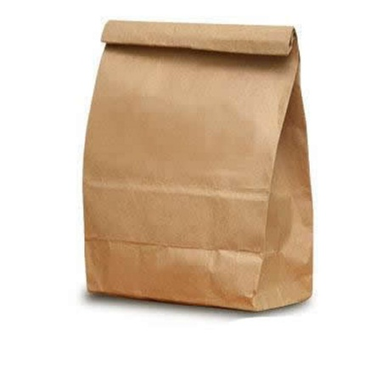
Here’s a list of ingredient ideas:
- Peanut or Sun Butter (in 2 oz. container w/ lid)
- Hummus (in 2 oz. container w/ lid)
- ½ Whole Wheat Pita or Slice of Bread (in ziplock bag)
- Fruit (in ziplock bag):
  - Grapes
  - Berries
  - Clementine
- Celery (in ziplock bag)
- Carrots (in ziplock bag)
- Raisins (mini boxes)

Place all ingredients paper bag and have fun!

