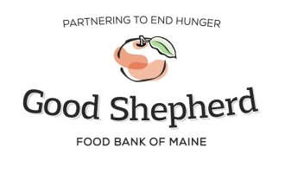
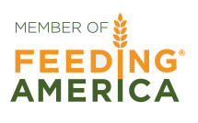
Community Health and Hunger Program

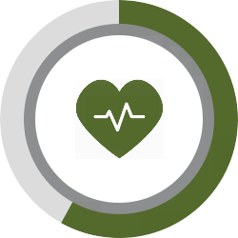
The Community Health and Hunger Program addresses the issue of nutrition and health in low-income families by seeking to increase the integration of health care and emergency food delivery to low-income and food-insecure Mainers. In turn, this improves health outcomes and limits the effects of food insecurity as a contributor to chronic disease.
One in seven Mainers is food insecure, meaning they lack regular access to nutritious foods. Simultaneously, one in three Mainers is considered obese. Maine ranks first in New England for food insecurity AND first in obesity and Type II diabetes*, two diet-related conditions often exacerbated by food insecurity. Lack of adequate nutrition can impair an individual’s ability to treat and prevent conditions such as Type II diabetes, hypertension, and obesity, and can prevent them from successfully managing other chronic health conditions. Good Shepherd Food Bank’s Community Health and Hunger Program is committed to partnering with health care providers to connect food insecure patients with community resources and the food they need to better manage their health needs.
The CHH program builds partnerships between the Food Bank and health care organizations so together we may better identify and remove barriers for Mainers who lack access to enough nutritious food to live healthy lives. This is accomplished through two main activities: empowering health care providers to increase access to healthy food for patients identified as food insecure and building the capacity of community-based hunger-relief programs to provide consistently available healthy foods such as fruits and vegetables.
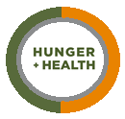
Program Details
Good Shepherd Food Bank provides training to health care partners interested in implementing the Hunger Vital Signs™ Food Insecurity Screening questions as part of routine patient visits. The Food Bank can also provide health care partners with pre-packed emergency food bags for direct and immediate distribution to those who identify as food insecure. These bags, purchased by the healthcare center for $10 each and provided to patients at no cost, can provide 2-3 days of nutritious shelf-stable food to patients struggling to manage a chronic illness. Each health care partner is also provided with a list of local emergency food access points to offer to patients that screen positive for food insecurity. In addition, the Food Bank works closely with local partner agencies to support successful referrals from the health care partner to the community’s local pantry.

For more information on Good Shepherd Food Bank’s Community Health and Hunger Program and how you can get involved, please contact Laura Vinal, Program Manager, at 207.782.3554 ext. 1138 or at lvinal@gsfb.org.

