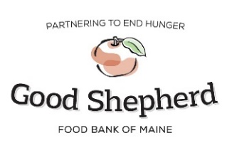
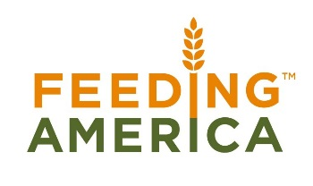

Retail Store Donation Tracking Form
Agency:
Store Name and Location: Date:

Submit Poundage Reports WEEKLY through the online system.
Any questions or concerns contact your Community Resource Representative.
*FOR WEIGHTS: UTILIZE SCALE THAT HAS BEEN PROVIDED*
Estimated Poundage per Category (see estimate below for each category based on a bananas box of that product)
Date(s) >>>
Bakery 25lbs
(Cakes, cookies etc.)
Bread 20lbs
(All bread items)
Dairy 40lbs
(All dairy products)
Eggs
(by the dozen)
Dry Goods 28lbs
(shelf stable)
Meals 40lbs
(Refrigerated dinners, sandwiches, salads etc.)
Meat 35lbs
(Pork, beef, poultry, etc.)
Mix Frozen 35lbs
(Frozen items besides meat)
Non Food 35lbs
(Cleaners, personal items etc.)
Produce 35lbs
(fresh fruits and vegetables)

COMMENTS
______________________________________________________________________________________________________________________________________

