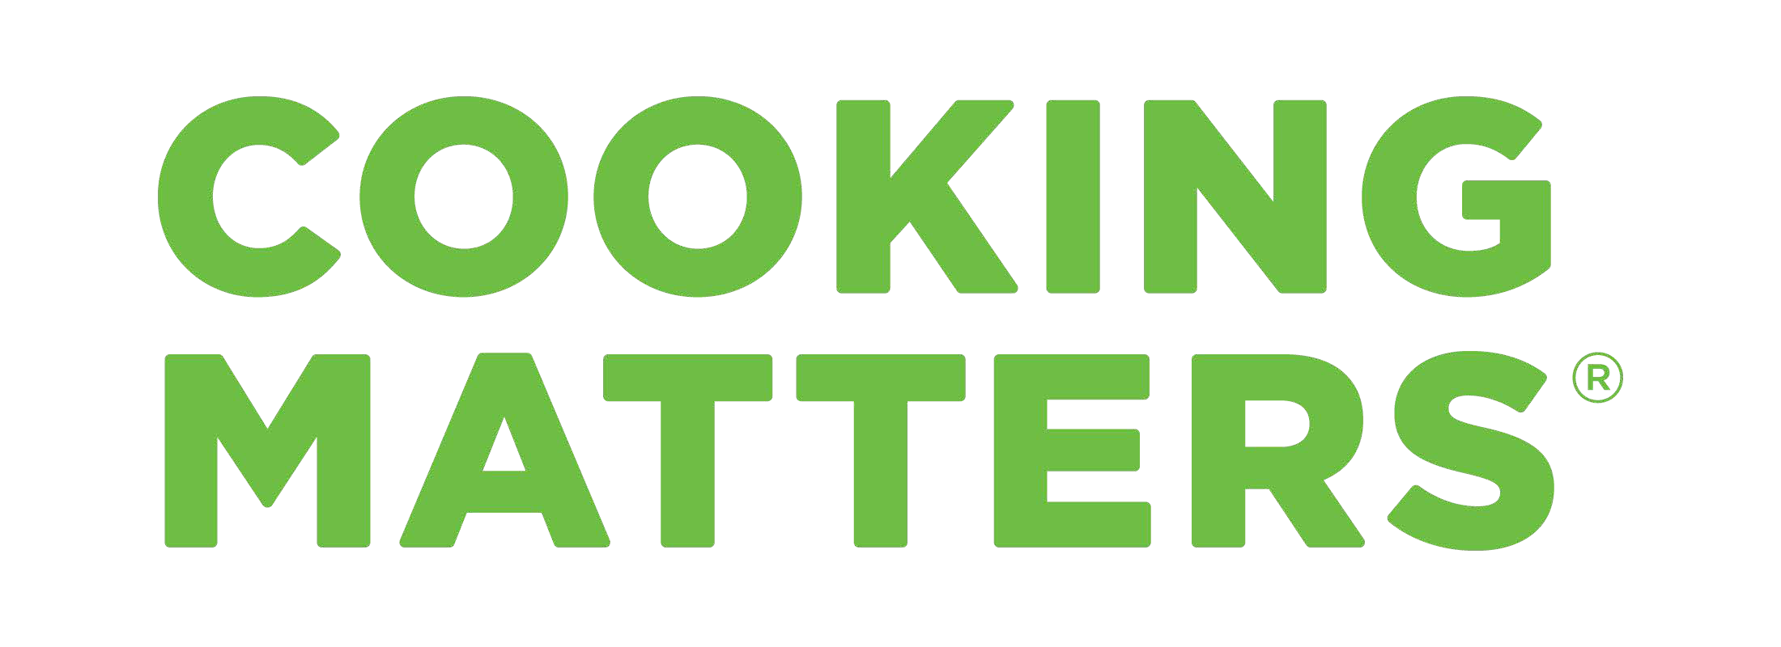**Cooking Matters has seven flexible format sessions that can be offered in either 30 or 60 minute lengths both in person and online. We offer the sessions in a series of 6 classes.**

# Kids Say Yes to Fruits & Veggies

This session will discuss pros and cons of using different forms of fruits and vegetables, how to prepare meals and snacks that help kids eat more fruits and vegetables, and share ideas for helping kids enjoy more fruits and vegetables.

# Making Recipes Work For You

This session will discuss how to substitute ingredients in recipes, practice using recipe frameworks, and share meal ideas that allow each family member to choose the toppings or ingredients that they enjoy.

# No More Mealtime Madness

This session will introduce fundamentals of maintaining a basic pantry and discuss ways to involve kids in the meal planning to create more buy-in at mealtime.

# Hack Your Snack

This session will share tips for saving time when buying and preparing healthy snacks, practice making healthy, homemade snacks, reading food labels, and identifying healthier choices when choosing prepackaged snacks, and practice comparing unit prices to save money.

# The Family Kitchen

This session will prepare caregivers to work together with kids in their care to discuss safe, age- appropriate tasks for kids in the kitchen, practice preparing meals or snacks with child-friendly steps, and make healthy meals and snacks that everyone will enjoy.

# Money-Saver Alert

This session will discuss how to use everything that you have (or have access to), practice using ‘hard to utilize’ ingredients in a variety of recipes, and discuss how to save foods that you

can’t use right away and how to limit food waste with children while still introducing new foods.

# Drink To Your Health

This session will discuss how sugary drinks affect health and describe how to make and taste a variety of healthy beverages at home.

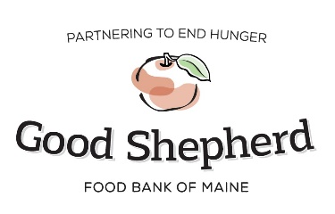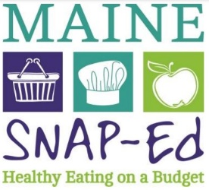

Include contact info here